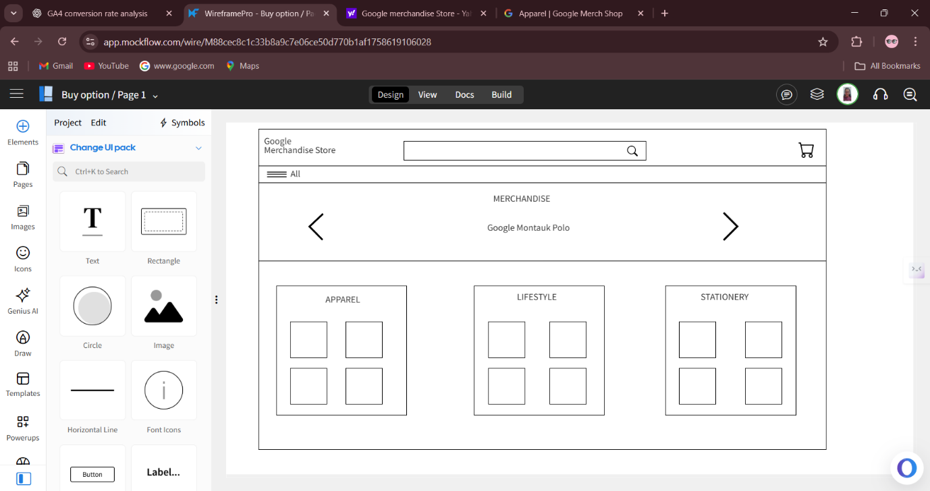

Wireframe 2 : Updated Home Page of Google Merchandise Store

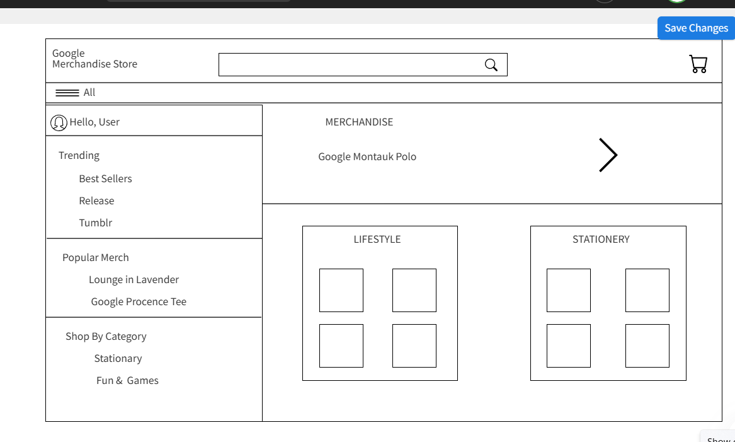

Wireframe 3: category Page Overlapped on home page